SUMMER SEMESTER 2024  
MTH1060A : ANALYTICAL AND COMPUTATIONAL FOUNDATIONS   
INSTRUCTOR: MR FRANCIS OCHIENG’  
DATE: 29/7/2024  
  
GROUP 14  
NATHAN ORANG’O OMENGE: 670637  
MARANGA ZIZA: 669613  
RENCIA SEDA: 668884

USIU-AFRICA

Table of Contents

Introduction 3

Methodology 4

Results and Analysis 5

Vaccination Strategies 7

Vaccination Strategies 8

Vaccination Strategies 9

Social Distancing Strategies 11

Combined Mitigation Strategies 15

Comparative Analysis 18

Conclusions and Recommendations 19

References 20

Introduction

This report details the results and analysis of agent based epidemic modelling simulations, designed to investigate the spread of an epidemic in a population and the efficacy of various mitigation strategies in reducing the spread of the epidemic.

Our task was to model the progression of an infectious disease within a selected population and analyse the effectiveness of two mitigation strategies; vaccination and social distancing; on controlling the outbreak.

#### Definition of Key Terms

##### Agent Based Modelling (ABM)

A computational method that simulates the actions and interactions of autonomous agents to understand the behavior of a system as a whole (Bonabeau, 2002).

##### Epidemic

The rapid spread of an infectious disease to a large number of people in a given population within a short period of time (Centers for Disease Control and Prevention [CDC], 2012).

##### Mitigation Strategies

Interventions aimed at reducing the impact of a disease outbreak, such as vaccination and social distancing (World Health Organization [WHO], 2020).

##### Vaccination

The administration of a vaccine to stimulate an individual's immune system to produce antibodies and provide immunity against one or several diseases (CDC, 2021).

##### Social Distancing

The practice of maintaining physical space between people to reduce the spread of infectious diseases (CDC, 2020).

Methodology

We developed and implemented our agent based model (AGM) using MATLAB. Our model simulates a population of 1,000 agents in a confined space over a period of 100 days. The key parameters of the model include:

1. Initial infected population: 5 agents
2. Infection radius: 2 units
3. Infection probability: 0.3 (30% chance of infection upon contact)
4. Recovery time: 14 days

We implemented two primary mitigation strategies:

1. Vaccination: Agents have a daily probability of being vaccinated, which reduces their susceptibility to infection.
2. Social Distancing: Reducs the movement range of agents, thereby decreasing the likelihood of contact between infected and susceptible individuals.

The model was run under various scenarios to evaluate the effectiveness of these strategies both individually and in combination.

Results and Analysis

Baseline Scenario: No Mitigation

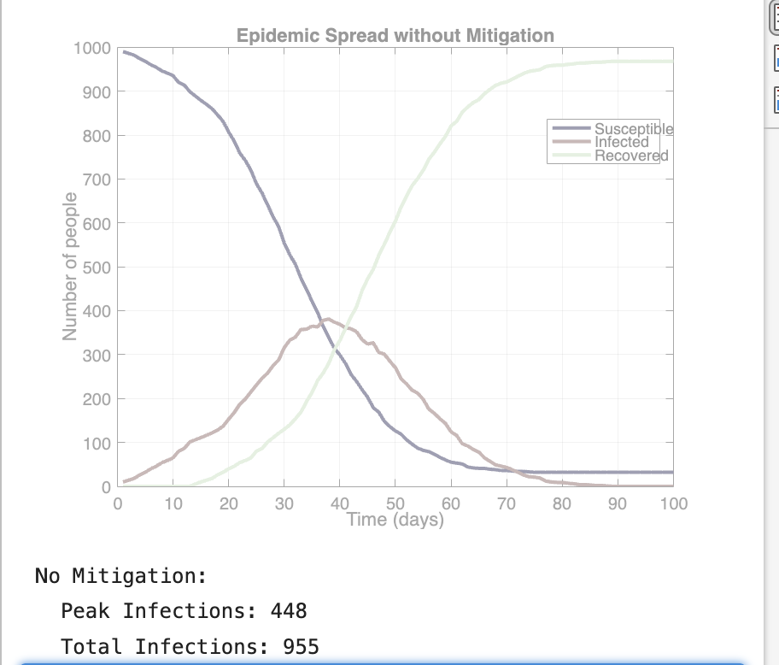

In the absence of any mitigation strategies, the model shows a rapid spread of the infection through the population.

The infection curve exhibits a sharp initial increase followed by a peak and then a gradual decline as the number of suseptible individuals decreases, a pattern typically exhibited by epidemic curves. ]

Key Observations:

1. Peak Infection Rate: 448 Individuals
2. Total Infections: 995 Individuals

Vaccination Strategies

We simulated infection spread with various daily vaccination rates (0.1%, 0.5% and 1% of the total population).

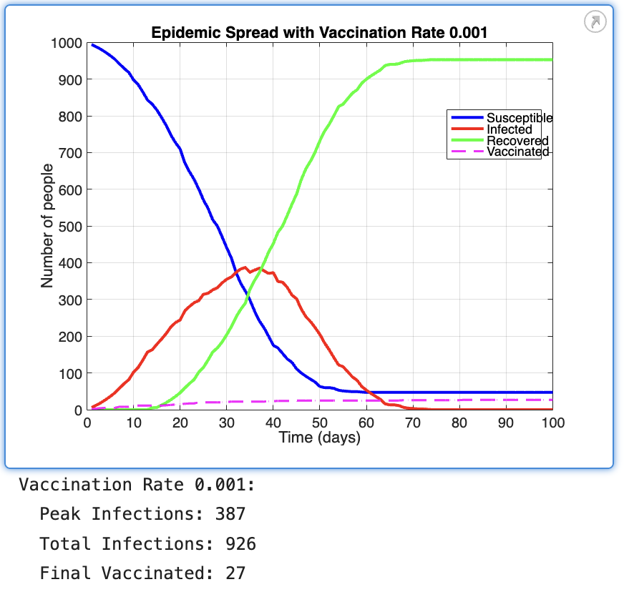

Key Observations:

* 1. Peak Infections: 387 Individuals
  2. Total Infections: 926 Individuals
  3. Total Vaccinated Individuals : 27 Individuals

Vaccination Strategies

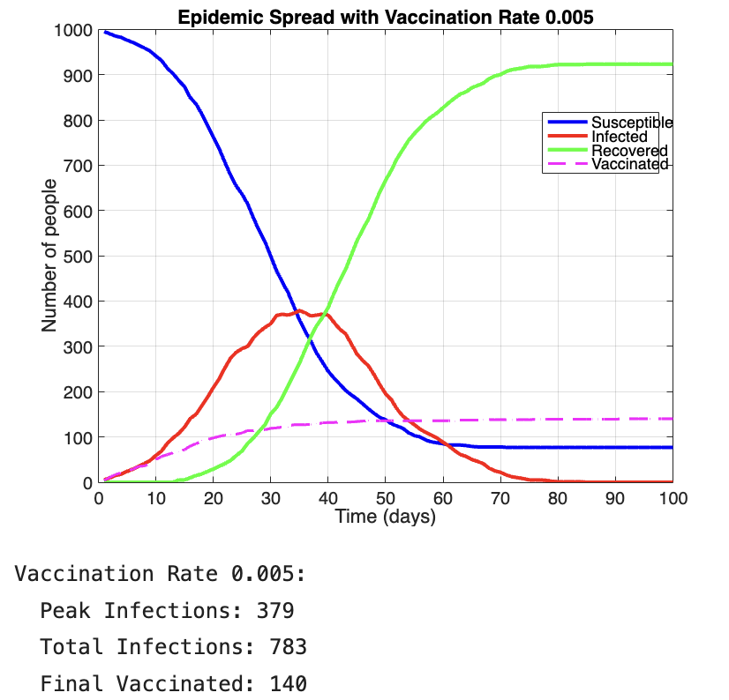

Key Observations :

1. Peak Infections: 379 Individuals
2. Total Infections: 783Individuals
3. Total Vaccinated Individuals : 140 Individuals

Vaccination Strategies

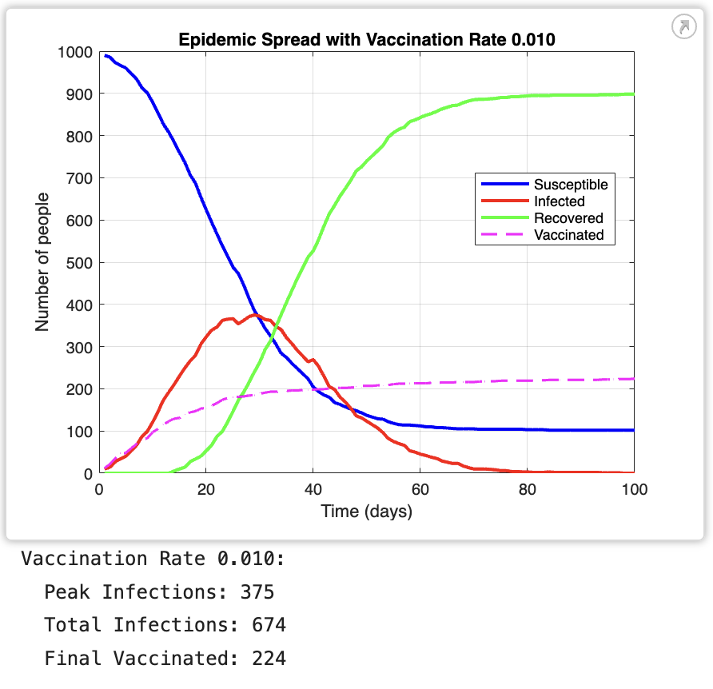

Key Observations:

1. Peak Infections: 375 Individuals
2. Total Infections: 674 Individuals
3. Total Vaccinated Individuals : 224 Individuals

Increasing vaccination rates showed a clear trend in reducing both peak infection rates and total infections.

Even at the lowest rate, vaccination had a noticeable impact on slowing the spread of the epidemic.

The highest vaccination rate demonstrated the most significant reduction in infections, suggesting that rapid and widespread vaccination can be a highly effective mitigation strategy.

Social Distancing Strategies

We simulated different levels of social distancing (25%, 50% and 75% reduction in movement)

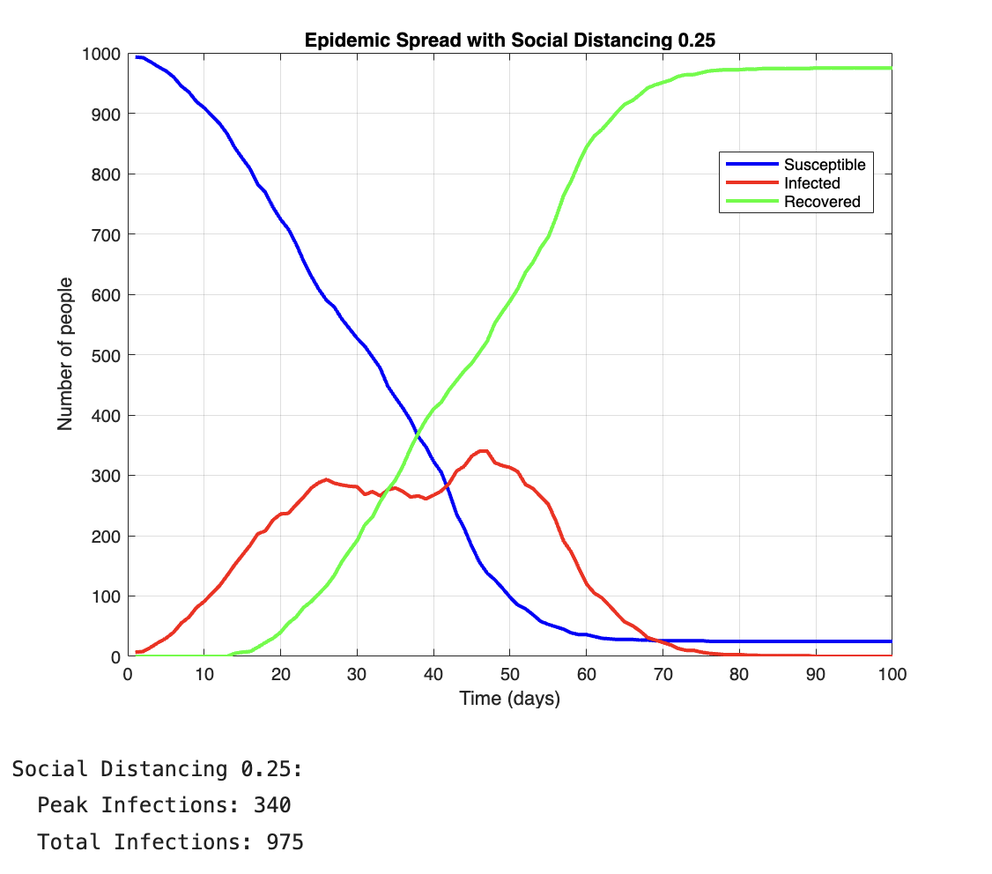

Key Observations:

1. Peak Infections: 340
2. Total Infections: 975

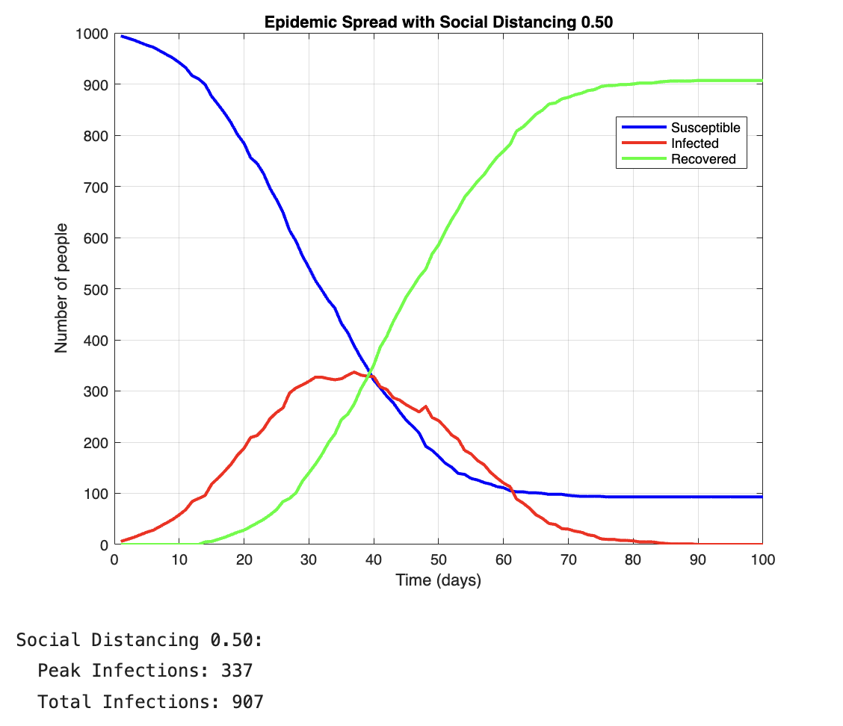

Key Observations:

1. Peak Infections: 337
2. Total Infections: 907

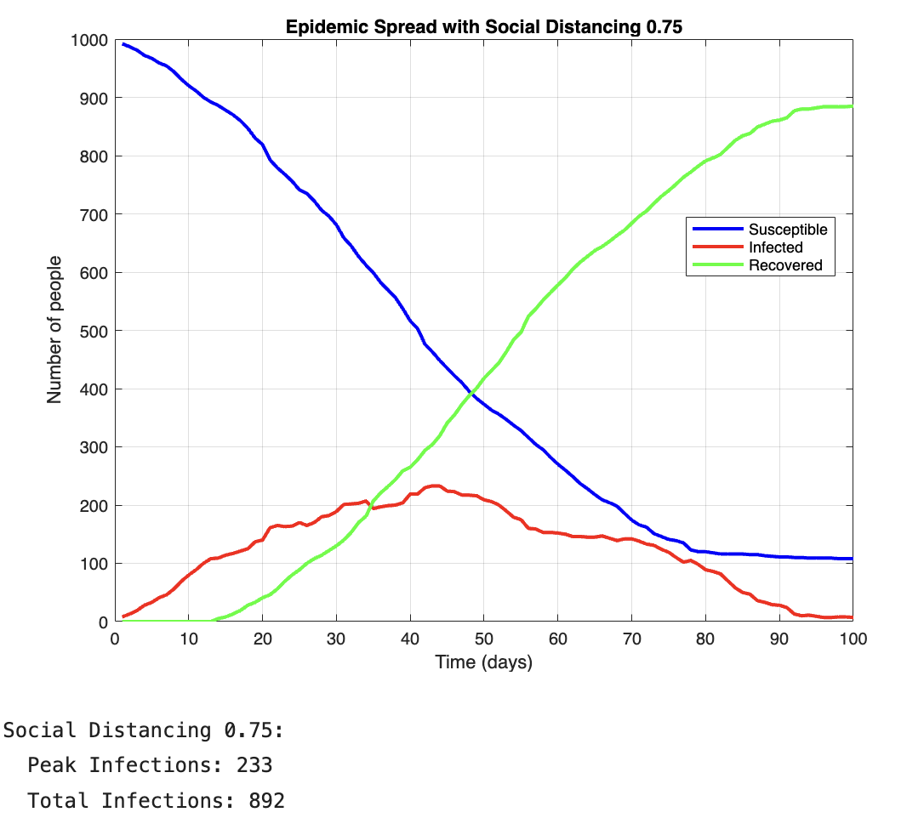

Key Observations:

1. Peak Infections: 223
2. Total Infections: 892

Social distancing proved to be an effective strategy for flattening the infection curve.

Higher levels of social distancing led to more significant reductions in peak infection rates and delayed the timing of the peak.

Combined Mitigation Strategies

Here, we investigated the effects of combining vaccination and social distancing strategies at moderate and high levels

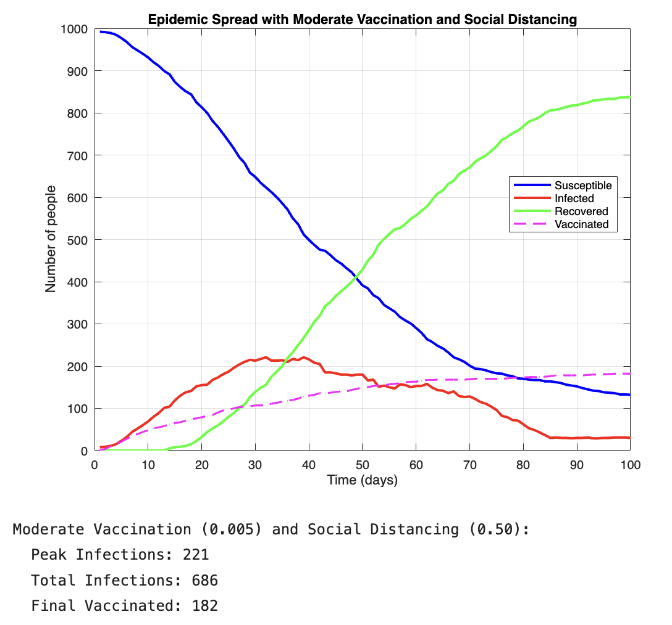

Key Observations:

1. Peak Infections: 221
2. Total Infections: 686
3. Final Vaccinated: 182

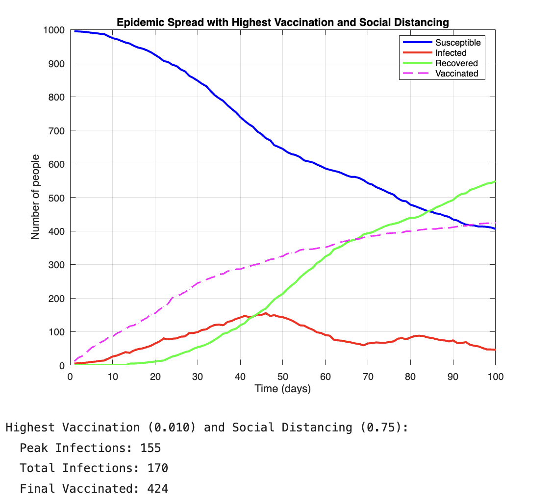

Key Observations:

1. Peak Infections: 155
2. Total Infections: 170
3. Final Vaccinated: 424

The combination of vaccination and social distancing showed synergistic effects in mitigating the epidemic. The scenario with the highest levels of both strategies demonstrated the most dramatic reduction in infections, significantly outperforming either strategy used in isolation.

Comparative Analysis

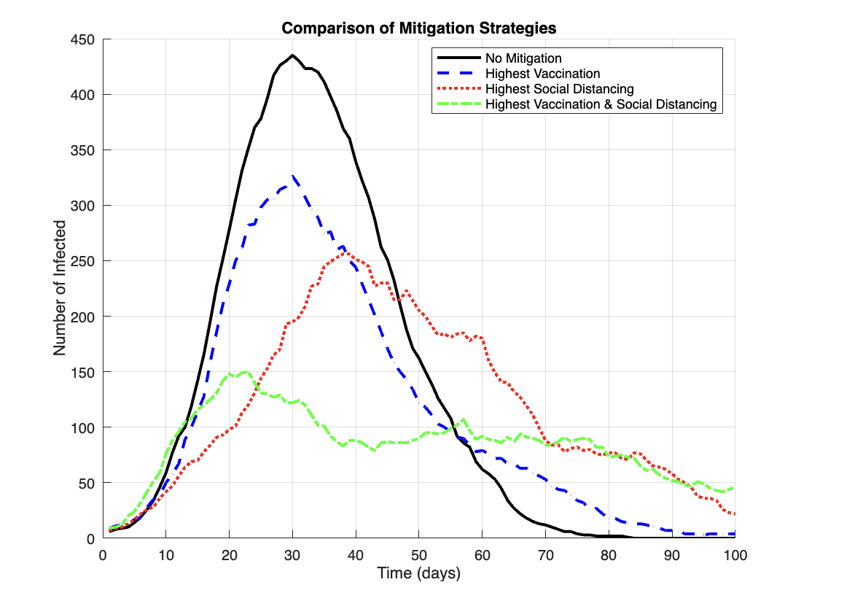

The simulations we ran clearly illustrates the relative effectiveness of different mitigation strategies:

1. No mitigation resulted in the highest peak and fastest spread.
2. Vaccination alone showed a gradual but steady impact on reducing infections.
3. Social distancing alone was effective in flattening the curve and delaying the peak.
4. The combination of high vaccination rates and social distancing measures proved most effective in controlling the epidemic.

Conclusions and Recommendations

#### Conclusions

1. Both vaccination and social distancing are effective in mitigating epidemic spread, but their impacts differ in nature and timing.
2. Vaccination is particularly effective in reducing the overall number of infections over time.
3. Social distancing is crucial for immediate impact and for "flattening the curve."
4. The combination of both strategies provides the most robust approach to epidemic control.

#### Recommendations

1. **Implement a combined approach**: Given that the combination of vaccination and social distancing showed synergistic effects in mitigating the epidemic, it is recommended to adopt a multi-faceted approach to epidemic control.
2. **Prioritize rapid vaccination**: The simulations demonstrated that higher vaccination rates led to significant reductions in total infections. Therefore, it is crucial to implement swift and widespread vaccination programs during an outbreak.
3. **Enforce social distancing measures**: Social distancing proved effective in flattening the infection curve and delaying the peak. Policymakers should consider implementing and enforcing social distancing measures, especially in the early stages of an outbreak.
4. **Adjust strategies based on epidemic phase**: As the effectiveness of strategies varied over time, it is recommended to adapt mitigation measures according to the current phase of the epidemic.

References

Bonabeau, E. (2002). Agent-based modeling: Methods and techniques for simulating human systems. Proceedings of the National Academy of Sciences, 99(suppl 3), 7280-7287. <https://doi.org/10.1073/pnas.082080899>

Centers for Disease Control and Prevention. (2012). Principles of Epidemiology in Public Health Practice (3rd ed.). U.S. Department of Health and Human Services.

Centers for Disease Control and Prevention. (2020). Social Distancing. https://stacks.cdc.gov/view/cdc/90522

Centers for Disease Control and Prevention. (2021). Vaccines and Immunizations. https://www.cdc.gov/vaccines/vac-gen/imz-basics.htm#:~:text=Vaccination%3A%20The%20act%20of%20introducing,interchangeably%20with%20vaccination%20or%20inoculation.

World Health Organization. (2020). Coronavirus disease (COVID-19) technical guidance: Infection prevention and control. https://www.who.int/emergencies/diseases/novel-coronavirus-2019/technical-guidance/infection-prevention-and-control/